Ruthenet (Benepe) Watkins
May 9, 1803 – November 13, 1874

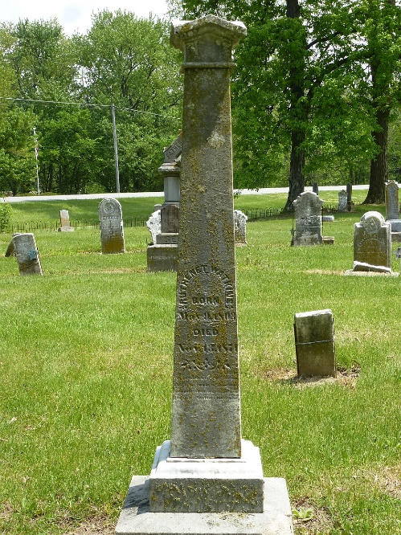
Photo by Elaine Mihm Geyer

Ruth Ruthenet Senatha Benepe from tree Sahl-Watkins Family Tree
Birth 9 May 1803 Baltimore, Maryland, USA
Marriage 26 Jan 1819 Tuscarawas, Ohio, USA
Residence 1870 Pleasant Mills, Adams, Indiana, USA
Death 13 Nov 1874 Adams, Indiana, USA
Father Dr. John Jacob Benepe (1763-1826)
Mother Harriet Amelia Warfield (1783-1844)
Spouse Jacob Snediker (Born 1800)
Spouse Jacob Watkins (Born 1800)

