Mary (Teeple) Watkins
March 12, 1838 – June 15, 1914

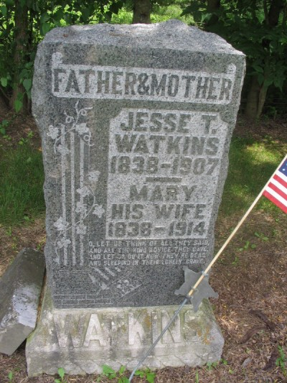
Photo by Margie Pearce

PIONEER IS DEAD Mrs. Mary Teeple Watkins Died at Pleasant Mills This Morning. ILL OF CANCER Was Seventy-six Years of Age -- List of Family of Fourteen

Another pioneer of the county, Mary Teeple Watkins, who resided with her daughter, Mrs. Sarah E. Ritter at Pleasant Mills, passed into that newer and higher life this morning at 1:15 o'clock, death being due to cancer of long standing. She was the widow of Jesse Watkins, and for more that fifty-five years had resided in Pleasant Mills and vicinity.
She was born in the state of Ohio, March 12, 1838, and last March 12, was seventy six years old. Her maiden name was Teeple, and she was the last one of a large family of fourteen brothers and sisters.
Mrs. Watkins was a member of the Christian church and was a woman well liked by all her friends. She leaves the following children: Sarah E. Ritter, Pleasant Mills; Wilson Watkins, Pittsburg, Pa.; James Watkins, Pleasant Mills; Mary E. Case, Dixon, O.; Stewart Watkins, Dixon, O.
The funeral will be held at the Baptist church at Pleasant Mills, in charge of the Rev. R. N. Ball of this city. The grandsons will serve as pall bearers. Mrs. Watkins' funeral will be held Thursday morning at ten o'clock.

Decatur Daily Democrat, Decatur, Adams County, Indiana
Monday, June 15, 1914

