John W. Watkins
November 15, 1835 – March 8, 1854

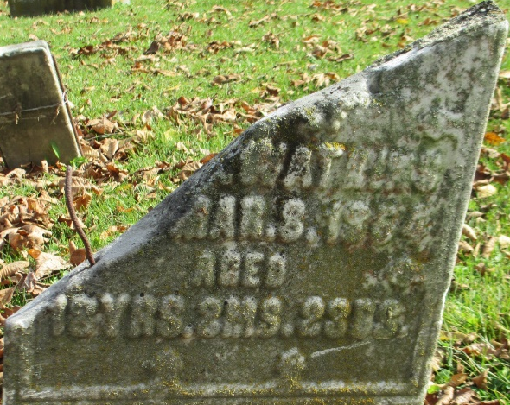
Photo by Elaine Mihm Geyer

John W Watkins from tree Griffiths Family Tree
Birth 15 Nov 1835 Ohio, USA
Residence 1850 Adams, Indiana, USA
Death 8 Mar 1854 Adams, Indiana, USA
Father W R Watkins (Born 1800)
Mother Ruthnetta Watkins (1803-1874)

