Eva L. (Acker) Vizard
May 27, 1871 – November 6, 1894

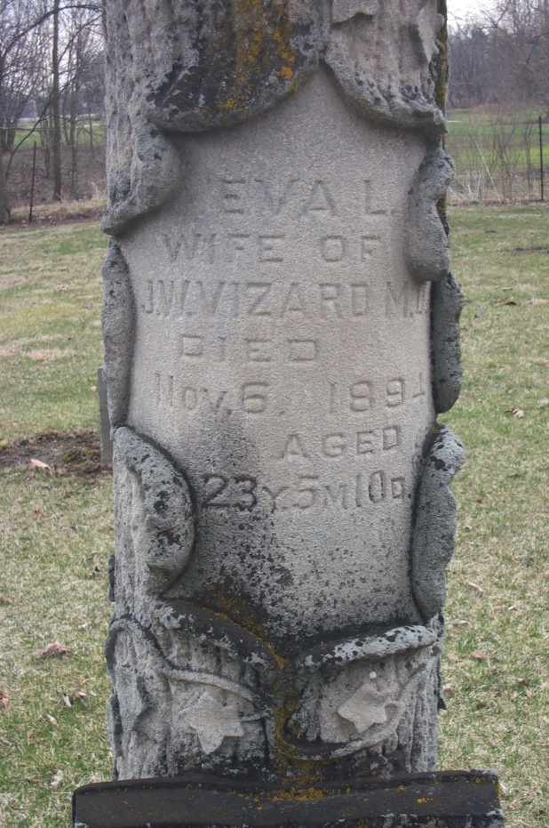
Photo by Deb Curry

Eva L Acker from tree Cagnet Family Tree
Birth 27 May 1871 Adams, Indiana, USA
Residence 9 Jun 1892 Monroeville, Allen, Indiana, USA
Marriage 7 Oct 1894 Pleasant Mills, Adams, Indiana, USA
Death 6 Nov 1894
Father Norman Acker (1832-1898)
Mother Loretta Acker (1837-1925)
Spouse John Wellington Vizard (1869-1935)

