Helen Thrailkill
January 26, 1914 – April 28, 1916

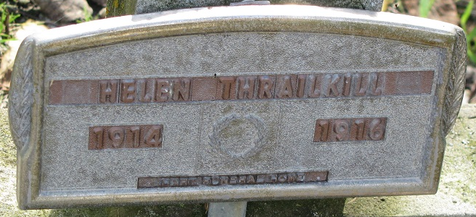
Photo by PLS

Helen Thrailkill
in the Indiana, U.S., Death Certificates, 1899-2017
Name Helen Thrailkill
Gender Female
Race White
Age 2
Birth Date 26 Jan 1914
Death Date 28 Apr 1916
Death Place Saint Marys, Adams, Indiana, USA
Death Registration Date 1916
Father Earl Thrailkill
Mother Anna Bender
Informant Anna Bender; Decatur, Indiana
Burial April 30, 1916; Pleasant Mills Cemetery

