Lillie May Thompson
September 22, 1891 – July 12, 1896

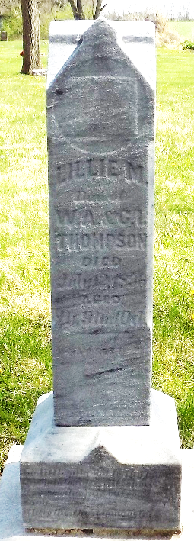
Photo by Deb Curry

Pleasant Mills Items

Lillie May, daughter of William and Libbie Thompson, was born October 2, 1894 and died July 12, 1896, aged one year, nine months, and two days. She was buried at the cemetery at this place Monday at half-past 10 o'clock. Funeral was conducted by Rev. Ryan at the U. B. Church

Decatur Democratic Press; Adams County, Indiana
July 16, 1896

**
Pleasant Mills Items

Lily May - Daughter of Wm. and Elizabeth Thompson, died Sunday morning of cholera infantum. Aged 1 year, nine months and 10 days. The funeral occurred Monday forenoon from the U. B. Church, conducted by Rev. Ryan of Greenwood. Lily was a sweet child and gifted with more than ordinary intelligence.
(Prayer)
The parents have our sympathy in their sad bereavement.

Decatur Democrat; Adams County, Indiana
July 17, 1896

**
Lillie M. THOMPSON from tree THOMPSON Family

Birth 22 Sep 1891 Allen, Indiana, USA
Death 2 Jul 1896 Allen, Indiana, USA
Father William Alexander THOMPSON (1860-1899)
Mother Catherine Isabel TINDALL (1866-1938)

