Elizabeth Ann (Carr) Thompson
1832 - 1894

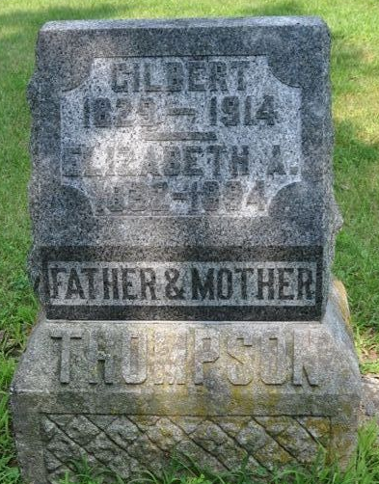
Photo by Deb Curry

Mrs. Gilbert Thompson of Pleasant Mills is lying in a critical condition. About three days ago she was crossing the railroad at that place carrying some articles in her hands, and by some cause slipped and fell, striking her head against the railroad rail, bruising her head very bad. The concussion was very severe and at this writing her recovery is doubtful.

Decatur Daily Democrat; Adams County, Indiana
Friday, January 12, 1894

**
Elizabeth Ann Carr from tree Michael Allan Horn
Birth 1832 Ohio, USA
Marriage 30 Mar 1854 Harrison, Ohio, USA
Residence 1880 Adams, Indiana, USA
Death 1897 Adams, Indiana, USA
Father John Carr (1810-1869)
Mother Sarah Kelly (1810-1867)
Spouse Gilbert Thompson (1829-1914)

