John Franklin Thomas
January 9, 1864 – September 3, 1891

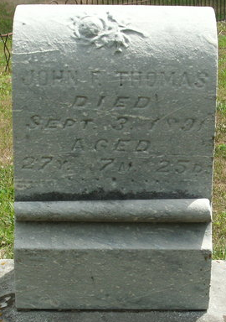
Photo by Barbara Baker Anderson

Indiana, Marriages, 1811-1959

groom: John Franklin Thomas
groom's place of birth: , , Indiana; groom's residence: , , Indiana; groom's number of marriage: 1st
groom's father: George Thomas; groom's mother: Mathison
bride: Ellen Brandsbery
bride's place of birth: , Adams, Indiana
bride's residence: , Adams, Indiana
bride's number of marriage: 1st
bride's father: John Brandbury; bride's mother: Harriet Smith
date of license: 02 Aug 1885
date of marriage: 02 Aug 1885; place of marriage: , , Indiana
record number: 5; digital folder number: 4186020; number of images: 1
**

John Franklin Thomas from tree Roop_File_2023-02-23
Birth 09 JAN 1864 • Magley, Adams, Indiana
Death 03 SEP 1891 • , Adams, Indiana?
Parents Unknown
Spouse Ellen Orpha Brandyberry 1868-1890

