George W. Thomas
August 8, 1849 – October 23, 1909

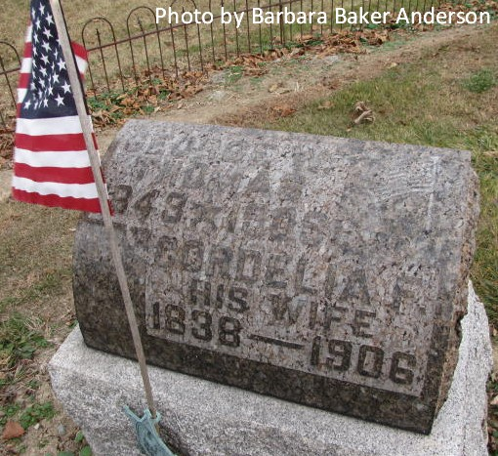

Indiana, Death Certificates, 1899-2011

Name: George W Thomas
Gender: Male
Race: White
Age: 66y, 2m, 15d
Marital status: Married
Birth Date: 8 Aug 1843
Birth Place: Ohio
Death Date: 23 Oct 1909
Death Place: Elkhart, Elkhart, Indiana, USA
Father: ??? Thomas
Mother: Manda Pany/Pavy
Spouse: Elsie Thomas
Informant: Edwina A. Thornton, Elkhart, Ind
Burial: Oct 26, 1909 - Decatur, Ind

