Ellen Orpha (Brandyberry) Thomas
June 24, 1868 – January 10, 1890

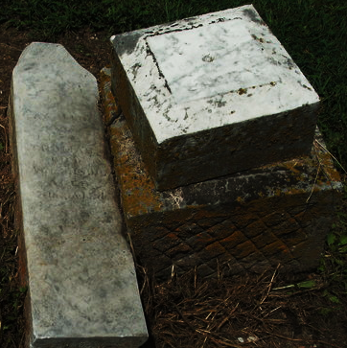
Photo by Deb Curry

Indiana, Marriages, 1811-1959

groom: John F Thomas
groom's race: White
groom's place of birth: , Adams, Indiana
groom's residence: , Adams, Indiana
groom's number of marriage: 1
groom's father: George Thomas; groom's mother: Mathenson
bride: Ellen Brandyberry
bride's race: White
bride's place of birth: , Adams, Indiana
bride's residence: , Adams, Indiana
bride's number of marriage: 1
bride's father: John Brandyberry; bride's mother: Harriet Smith
date of license: 01 Aug 1888
date of marriage: 04 Aug 1888; place of marriage: , , Indiana
digital folder number: 4186021; number of images: 1
**

Ellen Orpha Brandyberry from tree Roop_File_2023-02-23
Birth 24 Jun 1868 Allen, Indiana, USA
Marriage 4 Aug 1888 Bluffton, Wells, Indiana, USA
Death 10 Jan 1890 Allen, Indiana, USA
Father Jonathan Brandyberry (1838-1897)
Mother Harriet Smith (1832-1914)
Spouse John Franklin Thomas (1864-1891)

