Merle C. Suman
January 10, 1899 – August 24, 1899

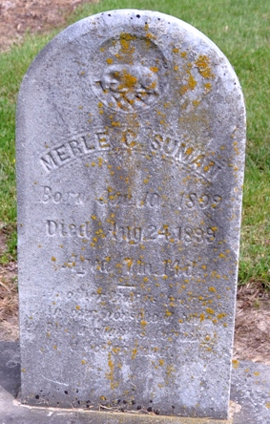
Photo by Deb Curry

Pleasant Mills Items

The little daughter of O. J. Suman and wife died last Thursday. Funeral occurred Friday afternoon at the M. E. church, conducted by Rev. Barton. Interment in Pleasant Mills Cemetery.

Decatur Democrat, Adams County, Indiana
Thursday, August 31, 1899

