Rebecca (Flagg) Stoops
November 17, 1843 – February 9, 1863

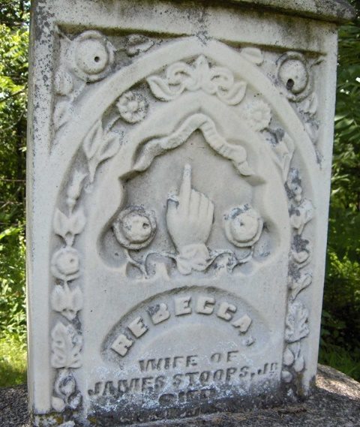
Photo by Margie Roop Pearce

Rebecca Flagg from tree Stoops---Fitch
Birth 17 Nov 1843 Indiana, USA
Residence 1860 Decatur, Adams, Indiana, USA
Marriage 10 Jan 1861 Adams Co IN
Death 9 Feb 1863 Adams Co IN
Father Samuel Flagg (1801-1882)
Mother Rebecca Flagg (1804-1860)
Spouse James Carr Stoops (1838-1919)

