Mary (McCarthy) Stevens
May 27, 1812 – January 9, 1879

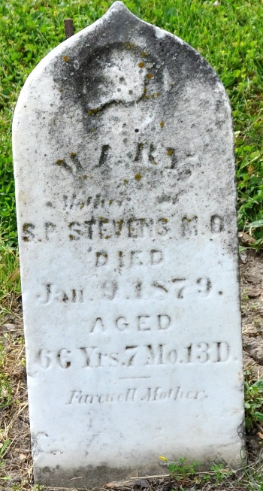
Photo by Deb Curry

Mary McCarthy from tree Stevens Family Tree

Birth 7 Mar 1810 Pennsylvania, USA
Death 15 Jan 1879 Adams, Indiana, USA
Spouse James E Stevens (1812-1877)

