Bertie Stetler
July 2, 1883 – December 21, 1885

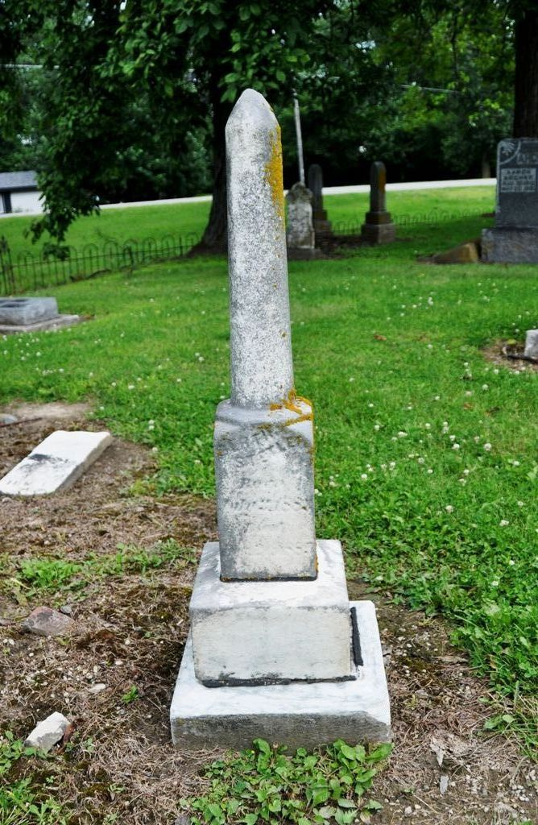
Photo by Deb Curry

Bert Stetler
in the Indiana, U.S., WPA Death Index, 1882-1920
Name Bert Stetler
Date Dec 21, 1885
Location Fort Wayne
Age 2 Yr
Gender Male
Race White
Source location City Health Office Fort Wayne
Source notes The source of this record is the book SCH-2 on page 73 within the series produced by the Indiana Works Progress Administration.

