Polly L. (McCristy) Steele
November 14, 1829 – September 8, 1907

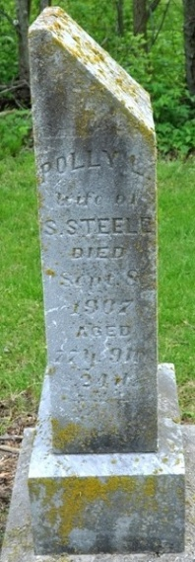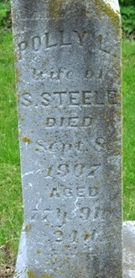

DEATH OF MRS. SAMUEL STEELE, ADAMS COUNTY PIONEER

Decatur, Ind. - Sept. 9 – After a long decline, Mrs. Samuel Steele died on Sunday morning at her home in St. Mary's Township. She was 78 years old and nearly all her life has lived in Adams County.
The obsequies will be at the United Brethren Church of Pleasant Mills at 2 o'clock Thursday afternoon, the Rev. Noah Stalter officiating. Interment will be made in the Pleasant Mills Cemetery.
She is survived by her aged husband and 3 sons, Ira Steele of this city, G. F. Steele of South Dakota and D. S. (sic) Steele of Kansas

Journal Gazette, Allen County, Indiana
Tuesday, September 10, 1907
**

Indiana, Death Certificates, 1899-2011

Name: Polly L Steele
[Polly L McCristy]
Gender: Female
Race: White
Age: 78y, 9m, 25d
Marital status: Married
Birth Date: 14 Nov 1829
Birth Place: Mercer Co Ohio
Death Date: 8 Sep 1907
Death Place: St Marys, Adams, Indiana, USA
Father: McCristy
Mother: Nancy ?Laler?
Spouse: Samuel Steele, informant
Burial: Sept 10, 1907; Pleasant Mills

