Henry Steele
May 13, 1832 – May 13, 1922

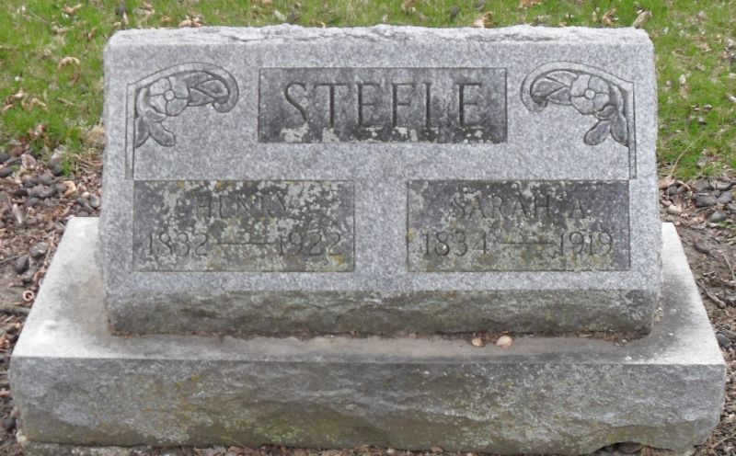
Photo by Stephen & Andrea Brangan

Pleasant Mills Man Succumbed Last Saturday
Henry Steel Died on the Ninetieth Anniversary of His Birth
Funeral Held Today
Worked at Carpenter Trade for Forty Years One Son Survives

Henry Steel, one of Adams county's oldest and well-known citizens, died on the ninetieth anniversary of his birth at the home of his son, J. H. Steele, in Pleasant Mills at 7 o'clock last Saturday evening. Death was caused by the infirmities of old age. The funeral services were held from the Methodist church in Pleasant Mills at o'clock this afternoon, the Rev. Maupin, officiating. Burial was held in the Pleasant Mills cemetery.
Mr. Steele was born in Bedford county, Pennsylvania, on May 13, 1832. He was the son of Mr. and Mrs. George Steele, and was one of thirteen children, all of whom are now deceased with the exception of one sister, Mrs. Alsena Hower, of St. Mary's township.
In 1848, Mr. Steele came to Adams county and settled in Kirkland township. In 1852, he was married to Miss Sarah Ann Coffman. To this union were born four children, three of whom are deceased. Mr. Steele moved to his home near Pleasant Mills. He worked at the carpenter trade for about forty years. Mrs. Steele died two years ago.

Decatur Daily Democrat, Adams County, Indiana
Monday Evening, May 15, 1922

