Dallas Weston Steele
June 19, 1859 – July 11, 1859

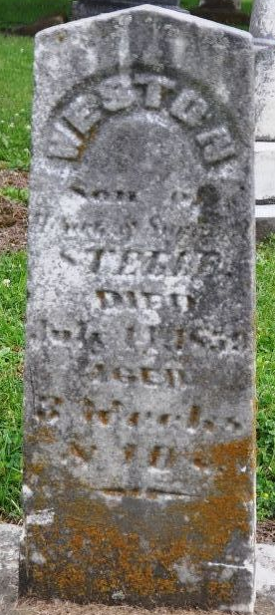
Photo by Deb Curry

Dallas Weston Steele from tree EvansSteele
Birth 19 Jun 1859 Adams, Indiana, USA
Death 11 Jul 1859 Adams, Indiana, USA
Father Henry Steele (1832-1922)
Mother Sarah Ann Coffman (1834-1919)

