William Wrey Smith
June 20, 1848 – November 9, 1930

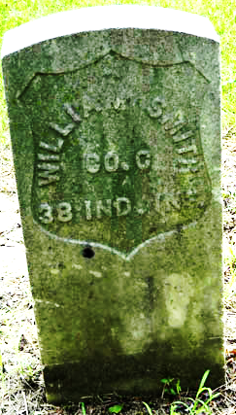
Photo by drbuck

William Wrey Smith
in the Indiana, U.S., Death Certificates, 1899-2017
Name William Wrey Smith
Gender Male
Race White
Marital Status Widowed
Age 82
Birth Date 20 Jun 1848
Birth Place Indiana
Death Date 9 Nov 1930
Death Place Muncie, Delaware, Indiana, USA
Death Registration Date 1930
Father Unknown [Robert Smith]
Mother Wrey [sic - Ray?]
Spouse Caroline
Informant Chas. F. McCullough; Auburn, Indiana
Burial November 11, 1930; Pleasant Mills, Indiana

