William Neil Smith
September 12, 1828 – March 29, 1864

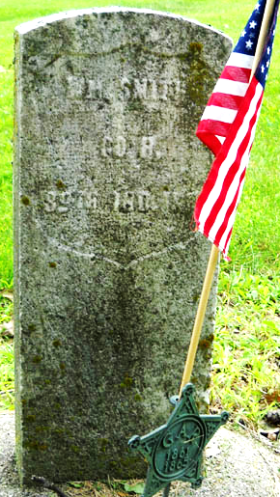
Photo by drbuck

Died while on leave from Civil War

William Smith Service: Civil War, Private, 89th Regiment, 3 year service, Company H. Pleasant Mills, Indiana. Mustered in 28 Aug 1862, died at home 29 Mar 1864. William died of dropsy during the Civil War. William was born 12 Sep 1828. He is the son of Joseph Smith and Lydia Reaves/Reeves.
Unknown source

**
U.S., Headstones Provided for Deceased Union Civil War Veterans, 1861-1904
Name William Smith
Date of Death 29 Mar 1864
Burial Place Near Decatur, Adams, Indiana, USA
Rank Pvt
Regiment 89th
Company H
Unit Ind Inf

**
William Neil Smith, Civil War Vet from tree Frye Family Tree
Birth 12 Sep 1828 Guernsey, Ohio, USA
Marriage 9 Mar 1854 Indiana, USA
Residence 1863 Pleasant Mills, Adams, Indiana, USA
Death 29 Mar 1864 Decatur, Adams, Indiana, USA
Father Joseph R Smith, Civil War & War 1812 Vet (1804-1888)
Mother Lydia Reeves (1810-1900)
Spouse Sarah A. Roop (1836-1897)

