Iven B. Shuman
August 17, 1870 – February 7, 1874

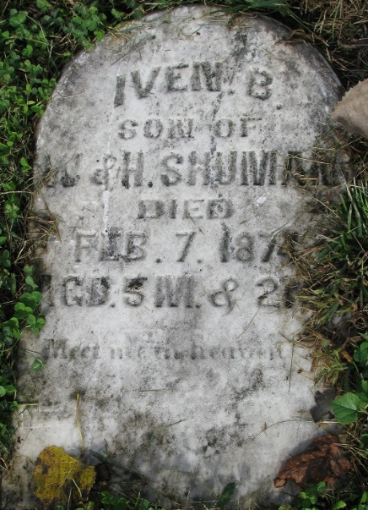
Photo by PLS

No further information found at this time

