Nancy (Gracy) Sewell
April 1, 1820 – January 11, 1879

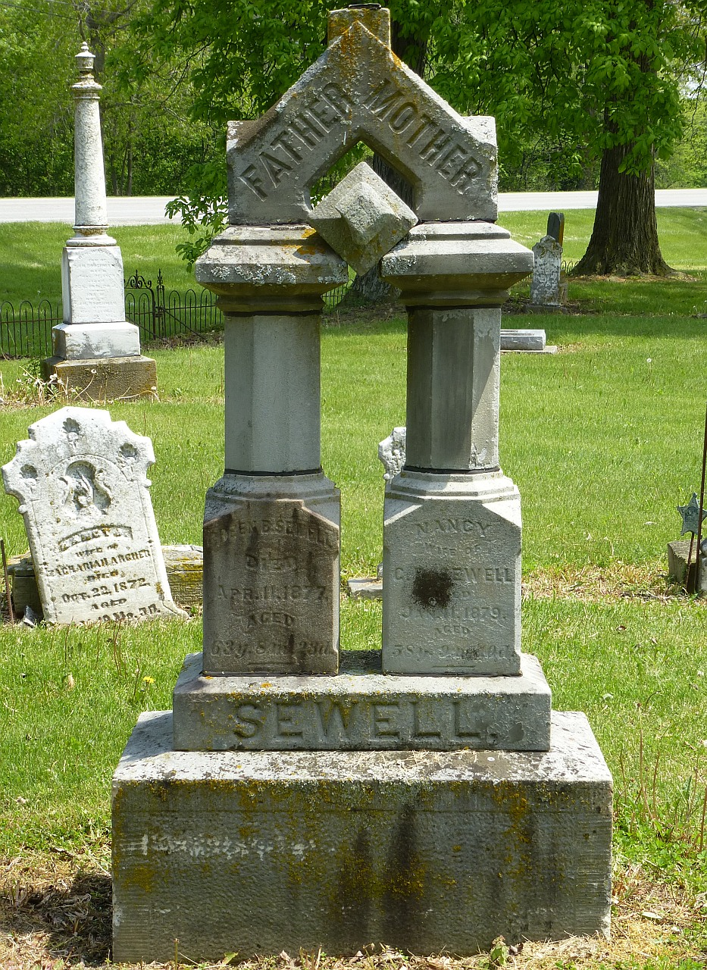
Photos by Deb Curry

Nancy Gracey from tree Dunlap Tree A3
Birth 1 Apr 1820 Harrison, Ohio, USA
Marriage 27 Apr 1837 Harrison, Hamilton, Ohio, USA
Residence 1850 Adams, Indiana, USA
Death 11 Jan 1879 Adams, Indiana, USA
Father George Gracey (1799-1851)
Mother Jane Gold (1805-1850)
Spouse Green Berry Sewell (1813-1877)

