Green Berry Sewell
July 18, 1813 – April 11, 1877

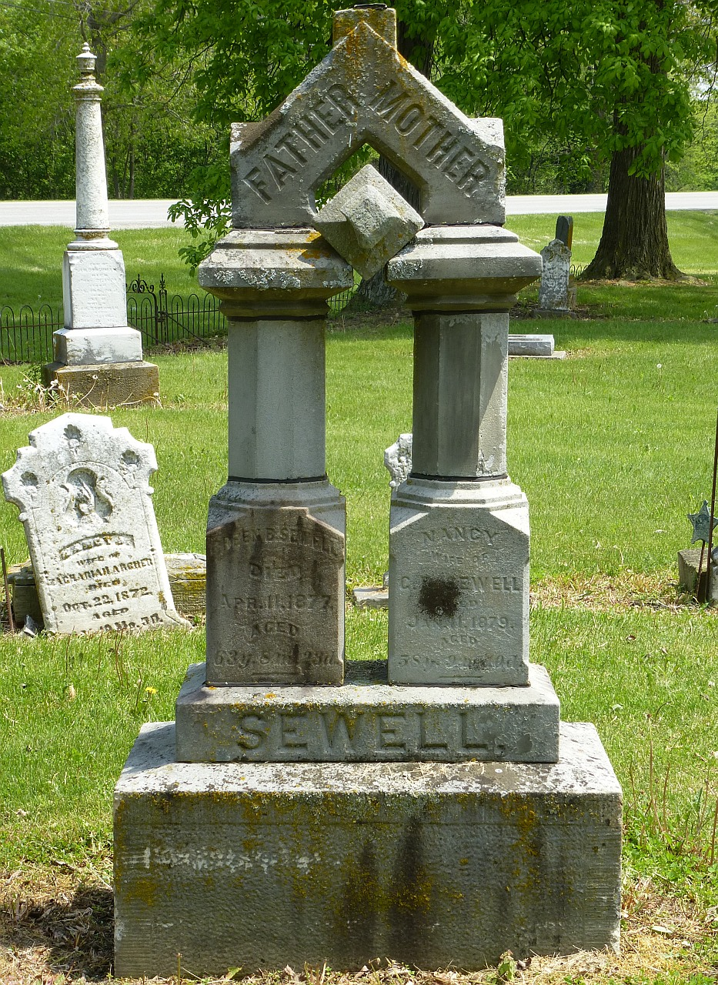
sPhotod by Deb Curry

Green B Sewell
in the Indiana, U.S., Wills and Probate Records, 1798-1999
Name Green B Sewell
Residence Date Abt 1877
Residence Place Adams, Indiana
Wife Nancy Sewell
One of heirs Hattie M. Einst
Will Date 26 Jan 1877
Probate Date 3 May 1877
Probate Place Adams, Indiana, USA
Death Date 18 April 1877
Inferred Death Place Indiana, USA
Case Number 229
Item Description Will Record, Vol A-C, 1839-1899
**
Green Berry Sewell from tree Sewell Family Tree
Birth 18 Jul 1813 Alexander, Athens, Ohio, USA
Marriage 27 Apr 1837 Harrison, Ohio, USA
Death 11 Apr 1877 Adams, Indiana, USA
Father Andrew Harvey Sewell (1772-1839)
Mother Eleanor BEALE (1780-1837)
Spouse Nancy Gracy (1820-1879)

