Edgar H. Schrank
- October 11, 1865

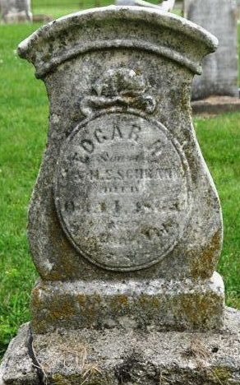
Photo by Deb Curry

No further information found at this time

