Isaac Hobbs Rose
March 31, 1790 – December 25, 1874

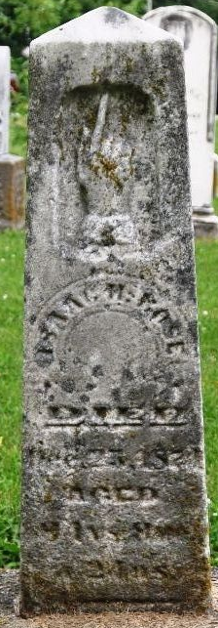
Photo by Deb Curry

Isaac Hobbs Rose from tree Hobbs Family Tree
Birth 31 Mar 1790 Chenango, Broome, New York, USA
Marriage 10 Aug 1813 Genoa, Cayuga, New York, USA
Residence 1870 Deerfield, Fulton, Illinois, USA
Death 25 Dec 1874 Adams, Indiana, USA
Father Jacob William Rose (1761-1839)
Mother Elizabeth Liza Bowker (1765-1846)
Spouse Anna Young (1795-1876)

