Anna (Young) Rose
January 12, 1795 – January 20, 1876

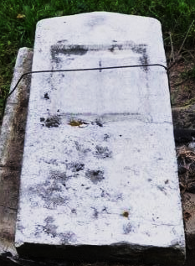
Photo by Deb Curry

Anna Young from tree rose Family Tree.
Birth 12 Jan 1795 Tioga, New York, USA
Marriage 10 Aug 1813 Genoa, Cayuga, New York, USA
Residence 1876 Glasgow, Howard, Missouri, USA
Death 20 Jan 1876 Adams, Indiana, USA
Father Christian John Young (1752-1838)
Mother Sarah Linderman (1766-1851)
Spouse Issac H. Rose (1790-1874)

