Elizabeth (Kemp) Roop
July 24, 1816 – December 21, 1891

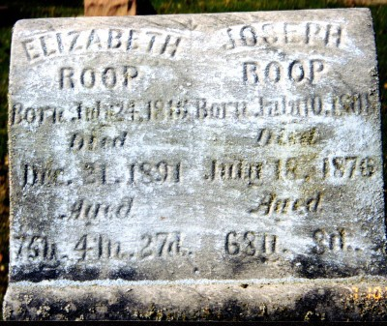
Photo by Margie Pearce

Died last Monday evening, Mrs. Eliza Roop, mother of Geo Roop. Funeral services were held at Pleasant Mills on Wednesday... Grandmother Roop, living 1/2 mile south of this place [Pleasant Mills] died Monday night and was buried Wednesday morning of this week. Funeral services were conducted by Rev. Freeman of the United Brethren Church.

Decatur Democrat, Adams County, Indiana
December 15, 1891

