Susa M. Roebuck
September 16, 1895 – August 19, 1897

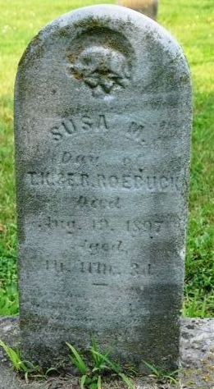
Photo by Deb Curry

Susan M. Roebuck from tree EvansSteele
Birth 16 Sep 1895 Adams, Indiana, USA
Death 19 Aug 1897 Adams, Indiana, USA
Father Anthony "Toney" K. Roebuck (1844-1907)
Mother Elsie R. Brown (Died 1907)

