Perry Roebuck
December 7, 1876 – December 10, 1927

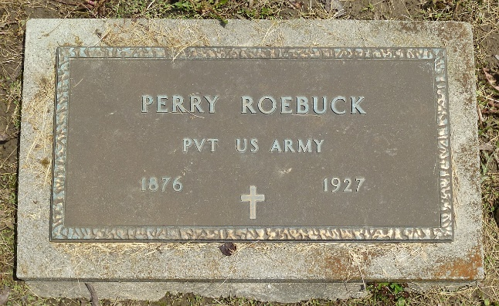
Photo by Deb Curry

Indiana, Marriages, 1810-2001

Name: Perry Roebuck
Gender: Male
Race: White
Age: 29
Event Type: Marriage Registration (Marriage)
Birth Date: 7 Dec 1876
Birth Place: Adams, Indiana
Marriage Date: 3 Mar 1906
Marriage Place: Indiana, United States
Residence Place: Pleasant Mills, Indiana
Father: Ebenezer Roebuck
Mother: Catharine Lewis
Spouse: Anna Railing
Page: 185
FHL Film Number: 002321466

**
Ohio, Death Records, 1908-1932, 1938-2018

Name: Perry Roebuck
Death Date: 10 Dec 1927
Death Place: Montgomery County, USA

**
U.S., Headstone Applications for Military Veterans, 1861-1985
Name Perry Roebuck
Rank Private
Birth Date 1876
Service Branch US Army
Unit Co. L, 29 Reg, of Infantry
Enlistment Date 11 Jun 1901
Discharge Date 10 Jun 1904
Death Date 1927
Cemetery Pleasant Mills
Cemetery Location Indiana
Applicant Perry Everett; grandson
**
Perry G Roebuck from tree Thomas Family Tree
Birth 7 Dec 1876 Allen, Indiana, USA
Marriage 3 Mar 1906 Allen, Indiana, USA
Residence 1924 Dayton, Montgomery, Ohio, USA
Death 10 Dec 1927 Montgomery, Montgomery, Alabama, USA
Father Ebenezer Roebuck (1840-1903)
Mother Lucinda Catherine Ellis (1845-1929)
Spouse Anna Shanno Buckmaster (1865-1936)

