Margaret M. (Steele) Roebuck
February 7, 1860 – August 7, 1884

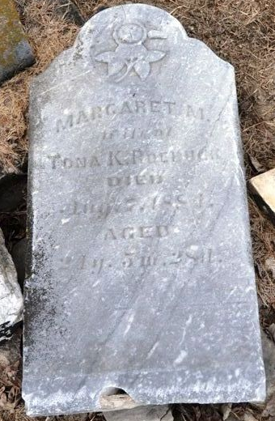
Photo by Deb Curry

Mrs. Roebuck, wife of Tona Roebuck, of Pleasant Mills, was buried last Friday. The deceased was about twenty-four years of age and had been suffering from consumption for several months.
She was the daughter of Samuel Steele and was loved and respected by all who knew her.
Funeral services were conducted by Rev. D. J. Schenck, of the U. B. Church.

Decatur Daily Democrat, Adams County, Indiana
August 15, 1884
**
Margaret M Steele from tree Benson
Birth 7 Feb 1860
Marriage 25 Oct 1883 Pleasant Mills, Adams, Indiana, USA
Residence Pleasant Mills, Adams, Indiana, USA
Death 7 Aug 1884 Indiana, USA
Father Samuel Steel (Born 1835)
Mother Polly Mcchristy (Born 1833)
Spouse Tona k Roebuck (1859-1927)

