John F. Roebuck
1834 – January 10, 1853

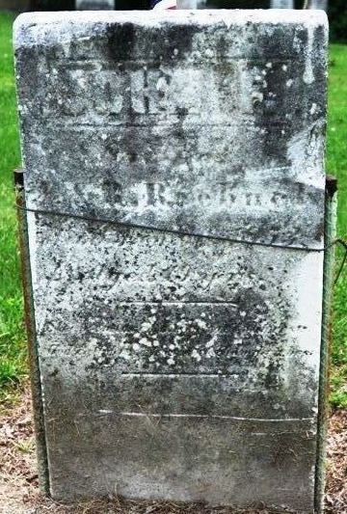
Photo by Deb Curry

John F Roebuck from tree John Orr Family
Birth 1834 Mercer, Ohio, USA
Death 10 Jan 1853
Father John Roebuck (1803-1836)
Mother Ruth Bevington (Roebuck) (Born 1802)
120625 People 2 Records 4 Sources

