Eddie Roebuck
August 16, 1878 – July 26, 1881

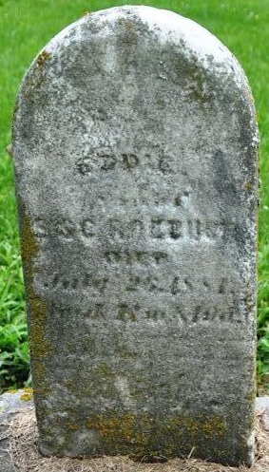
Photo by Deb Curry

Eddie Roebuck from tree gblanes
Birth 16 Aug 1878
Death 26 Jul 1881
Father Ebenezer Roebuck (1840-1903)
Mother Lucinda Catherine Ellis (1845-1929)

