Captolia L. Roebuck
June 27, 1863 – April 8, 1880

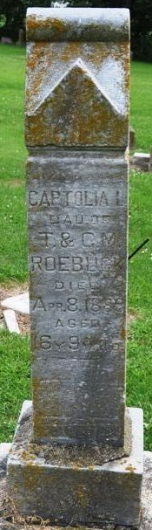c
Photo by Deb Curry

Decatur, Oct. 19 – Mrs. Anna Roebuck, 71, died at the Adams County Memorial Hospital Sunday evening of complications. She was born in Adams County, October 8, 1865, a daughter of Henry and Malinda Buckmaster. She married Jacob Railing in 1881 and he died in 1900. She then married Perry Roebuck in 1907, and he died in 1925.
Surviving are four children: Mrs. Maud Morgan, Monroe; Daniel and Morton Railing, at home; Forest Railing, Decatur Route 6. A brother, Atwood Buckmaster, resides at Montpelier. Funeral services will be held at the home at 2 pm Wednesday, with burial in the Pleasant Mills Cemetery.

Journal-Gazette, Allen County, Indiana
October 20, 1936

**
Indiana, U.S., Death Certificates, 1899-2017
Name Anna Shanna Roebuck
[Anna Shanna Buckmaster]
Gender Female
Race White
Marital Status Married
Age 71
Birth Date 8 Oct 1865
Birth Place Indiana
Death Date 18 Oct 1936
Death Place Decatur, Adams, Indiana, USA
Death Registration Date 1936
Father Henry Buckmaster
Mother Malinda Roe
Informant Mrs. Frank Majors; Monroe, Indiana
Burial October 21, 1936; Decatur Cemetery

