Anna M. (Bender) Roebuck
April 1, 1862 – August 27, 1887

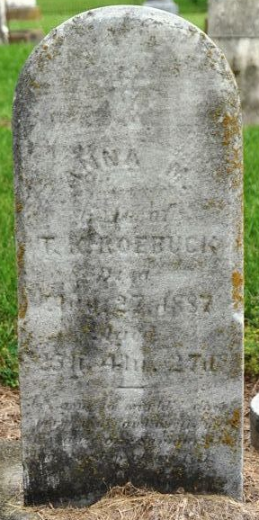
Photo by Deb Curry

Anna BENDER from tree glen anne's family_AutoBackup
Birth 1 Apr 1862
Marriage 31 Oct 1885
Death 27 Aug 1887
Father Jacob BENDER
Spouse Toney K. ROEBUCK (Born 1855)

