Albert A. Roebuck
July 17, 1867 – July 27, 1948

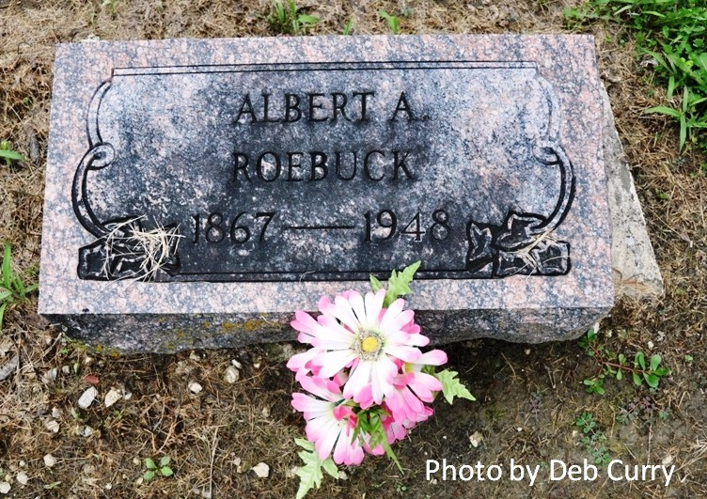

Indiana, Death Certificates, 1899-2011

Name: Albert Roebuck
Gender: Male
Race: White
Age: 81y, 0m, 10d
Marital status: Widowed
Birth Date: 17 Jul 1867
Birth Place: Adams County, Ind
Death Date: 27 Jul 1948
Death Place: Decatur, Adams, Indiana, USA
Father: Ebanezar Roebuck
Mother: Kathyrn Ellis
Spouse: Edith Boyd
Informant: Mrs. Harry Martz, Decatur, IN
Burial: 7/30/1948, Pleasant Mills Cemetery

