Russell Gordon Roe
January 11, 1903 – April 17, 1906

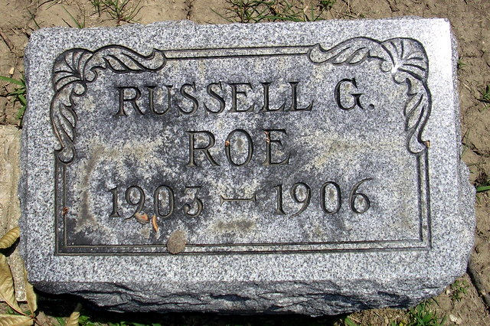
Photo by Deb Curry
IN MEMORIAM
Russell Gordon, only and beloved son of Mr. and Mrs. Jesse D. Roe, was born January 11, 1903 and departed this life April 17, 1906, aged 3 years, 3 months and 6 days.
He leaves to mourn their loss a broken hearted father and mother, one grandmother, one grandfather, and one great-grandmother, 3 aunts and many relatives, but he has gone to meet his little brother, Gillespie, who preceded him seven years ago.
Darling Russell was a sweet little boy, the pride of his parents and the favorite of his many acquaintances.
His future was one of speculation on the part of his parents, and the place made vacant by his sudden death can never be filled. The blow falls so heavily upon us was dealt in love and not in anger. He has been transformed into an angel, and the blessed comfort to his parents is the knowledge that his garb of purity and innocence was unspotted during the brief time allotted him here, the dove of immortality opened, and all that was mortal was put off and when the misty clouds of night be rolled away we will understand why one so young, so kind and affectionate should be called from our midst.
CARD OF THANKS
We wish to express our gratitude to the friends and neighbors for the kind assistance and sympathy rendered us during the illness and death of our little one.
Jesse and Ada Roe
Decatur Democrat, Adams County, Indiana
A weekly newspaper
Thursday, May 31, 1906
**
Indiana, Death Certificates, 1899-2011
Name: Russell Gorden Roe
Gender: Male
Race: White
Age: 3
Marital status: Single
Birth Date: 11 Jan 1903
Birth Place: St Marys TP Adams Co Ind.
Death Date: 17 Apr 1906
Death Place: St Marys, Adams, Indiana, USA
Father: Jesse D Roe
Mother: Ada Blausett
Burial: April 19, 1906; Pleasant Mills, Ind.

