Gillespie L. Roe
1897 - 1899

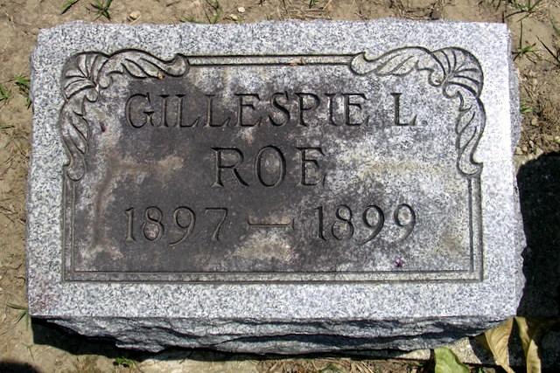
Photo by Deb Curry

No further information found at this time

