Catherine Jane (Smith) Roe
1844 - 1888

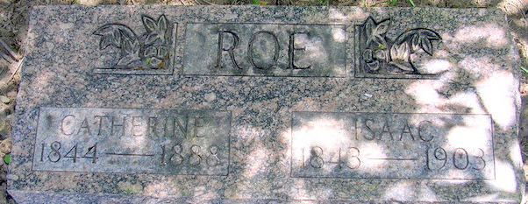
Photo by Deb Curry

Catharine Jane Smith - Roe from tree Lise' Cavelia Family Tree
Birth 1844 Ohio, USA
Marriage 15 Nov 1865 Allen, Indiana, USA
Residence 1880 Adams, Indiana, USA
Death 1888
Father John Henry Smith (1821-1891)
Mother Leah Delean Smith (1815-1894)
Spouse Isaac Roe (1843-1903)

