Tobartha (Thatcher) Robinson
December 12, 1841 – March 13, 1914

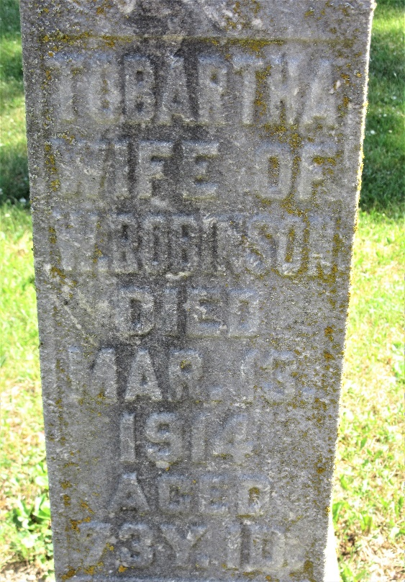
Photo by PLS

Indiana, Death Certificates, 1899-2011

Name: Tobartha Robinson
[Tobartha Thatcher]
Gender: Female
Race: White
Age: 73y, 3m, 1d
Marital status: Married
Birth Date: 12 Dec 1841
Birth Place: Van Ward Co, Ohio
Death Date: 13 Mar 1914
Death Place: St. Marys, Adams, Indiana, USA
Father: Jake Thatcher
Mother: unknown
Spouse: Bertha Robinson
Informant: Albert Bonner, Pleasant Mills, Ind.
Burial: March 15, 1914 - Pleasant Mills

**
Michigan, U.S., Marriage Records, 1867-1952
Name Bertha Bonar
[Bertha Thatcher]
Gender Female
Race White
Age 48
Birth Date abt 1852
Birth Place Indiana
Marriage Date 28 Nov 1900
Marriage Place Curtice, Midland, Michigan, USA
Residence Place Curtice Midland Co
Father Jacob Thatcher
Mother Nancy Thatcher
Spouse William W Robinson
Record Number 1035
**
Tabartha Thatcher from tree Richard K. Hill Family
Birth 12 Dec 1841 Indiana, USA
Marriage 28 Nov 1900 Curtis, Alcona, Michigan, USA
Residence 1910 Adams, Indiana, USA
Death 13 Mar 1914 Pleasant Mills, Adams, Indiana, USA
Father Jacob Thatcher (1811-1884)
Mother Nancy Gooden Thatcher (Born 1804)
Spouse James Boner (1840-1889)
Spouse William Wallace Robinson (1837-1923)

