Mary M. Raudenbush
February 21, 1895 – February 21, 1895

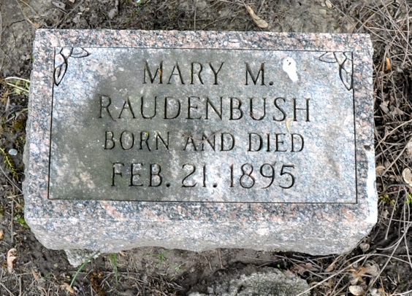
Photo by Deb Curry

Mary M. Raudenbush from tree Hopkins Family Tree
Birth 21 Feb 1895
Death 21 Feb 1895
Father Henry Dayton Raudenbush (1857-1942)
Mother Viola Estelle Roe Raudenbush (1872-1907)

