Henry David Raudenbush
August 9, 1857 – March 10, 1942

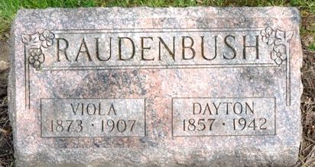
Photo by Deb Curry

Father of Monroe Women is Dead
Henry D. Raudenbush, 84, Dies at Adams County Hospital

Henry Dayton Raudenbush, 84, well known Adams County resident of near Craigville, died Tuesday morning at 6:50 o’clock at the Adams County Memorial Hospital. Death was attributed to infirmities following an extended illness.
The deceased was born in Elkhart County August 9, 1857, the son of Isaac and Anna Mary Shaeffer-Raudenbush. He was married in November, 1892, to Viola Rae, who preceded him in death 36 years ago. He had resided in Adams County practically his entire life.
Surviving are two daughters: Mrs. William Rupert of Monroe and Mrs. C. M. Laisure of Monroe; two sons: Clem of Craigville and Gun of Grand Rapids, Mich. and Guy of Grand Rapids, Michigan; four grandchildren and eight great-grandchildren. Two brothers, two sisters and a daughter are deceased.
Funeral services will be held Thursday afternoon at 2:00 o’clock at the St. Paul’s Church and burial will be in the Pleasant Mills Cemetery.

Adams County Historical Museum
February-November 1942 Scrapbook
Wednesday, March 11, 1942

**
Indiana, U.S., Death Certificates, 1899-2017
Name Henry Dayton Raudenbush
Gender Male
Race White
Marital Status Widowed
Age 84
Birth Date 9 Aug 1857
Birth Place Elkhart County, Indiana
Death Date 10 Mar 1942
Death Place Decatur, Adams, Indiana, USA
Death Registration Date 1942
Father Isaac Raudenbush
Mother Anna Mary Schaeffer
Spouse Viola Roe
Informant Clem Raudenbush; Craigville, Indiana
Burial March 12, 1942; Pleasant Mills Cemetery

