Morton A. Railing, Sr.
February 13, 1894 – October 31, 1976

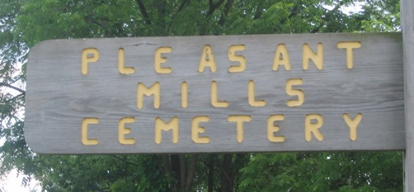
Photo by Margie Roop Pearce

Indiana, Death Certificates, 1899-2011

Name: Morton A. Railing Sr.
Gender: Male
Race: White
Age: 82
Armed forces: WW I
Marital status: Married
Birth Date: 13 Feb 1894
Birth Place: Indiana
Death Date: 31 Oct 1976
Death Place: Fort Wayne, Allen, Indiana, USA
Parents: not listed
Informant: Fort Wayne VA Hospital Records
Burial: 11-2-1976, Pleasant Mills Cemetery

