Delia (Briggs) Presho
October 1, 1793 – September 21, 1870

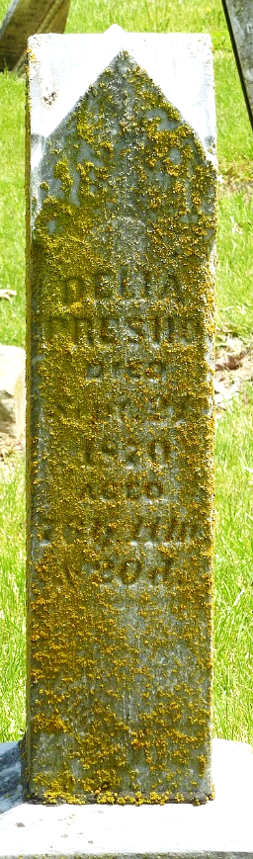
Photo by Jackie Sanders

Delviana Delila Delviana Briggs from tree Fuhrman Gunder Family Tree

Birth 1 Oct 1793 Westmoreland, Cheshire, New Hampshire, USA
Marriage 8 Sep 1814 Westmoreland, Cheshire, New Hampshire, USA
Residence 1860 Adams, Indiana, USA
Death 21 Sep 1870 Pleasant Mills, Adams, Indiana, USA
Father Ephraim Briggs (1761-1824)
Mother Deliverance "Dilla" Lewin (1762-1844)
Spouse Asa Presho (1793-1857)
2560 People 7 Records 13 Sources

