William P. Porter
1840 - October 7, 1900

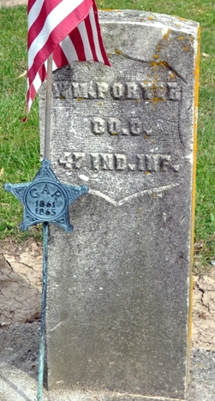
Photo by Deb Curry
The sad death of William P. Porter, of Pleasant Mills, occurred at the St. Joseph Hospital at Fort Wayne Sunday morning, at 8 o'clock, after an illness extending over several years. He was one of the best-known men of this county, was a veteran of the civil war, and probably contracted the peculiar combination of diseases which caused his death during his service. Several months ago he went to the Fort Wayne hospital, where he took treatment from his cousin, Dr. Miles Porter. His condition gradually grew worse and no medical skill could save him, death finally coming as a relief.
He was about sixty years of age and leaves two daughters, Mrs. Weisner of Fort Wayne, and Mrs. Gitsom, of Chicago. In speaking of his death, the Fort Wayne Journal of Monday said: "William P. Porter, a farmer residing near Decatur, died at St. Joseph Hospital Sunday morning at 8 o'clock, after a lingering illness. His affliction was of a peculiar nature affecting the liver and kidneys. The body was removed to the undertaking rooms of Shone & Veith, where a post mortem was conducted by Dr. Maurice Rosenthan, assisted by several physicians. A number of medical students also witnessed the autopsy. Mr. Porter came here for treatment about two months ago. He was sixty years old.
Surviving him are two daughters. One of them is Mrs. Nicholas Weisner, of 118 Thompson Street. Mr. Shone will take the body to Pleasant Mills Tuesday afternoon and the funeral service and interment will be at that place." The remains were sent to the G. R. & I. station here Tuesday morning by the G. A. R. members and were at once taken to Pleasant Mills, where the services were conducted at the Methodist Church by Rev. Peters.

Decatur Democrat; Adams County, Indiana
A weekly newspaper
Thursday, October 11, 1900
**

Indiana, U.S., Death Certificates, 1899-2017
Name William P Porter
Gender Male
Race White
Marital Status Widower
Age 60
Birth Date abt 1840
Birth Place Ohio
Death Date 7 Oct 1900
Death Place Fort Wayne, Allen, Indiana, USA
Death Registration Date 1899-1900
Parents Not named
Informant J. Wiessner; Fort Wayne, Indiana
Burial October 9, 1900; Pleasant Mills, Indiana
**

William P Porter* from tree Adams/Fox/Buckett/Pomroy/Masters
Birth 1840 Ohio, USA
Marriage 6 Apr 1865 Adams, Berkshire, Massachusetts, USA
Residence 1900 Adams, Indiana, USA
Death 7 Oct 1900 Fort Wayne, Allen, Indiana, USA
Father Francis Porter* (1818-1860)
Mother Margaret Johnson
Spouse Elizabeth Roebuck

