George W. Place
1832 – November 7, 1876

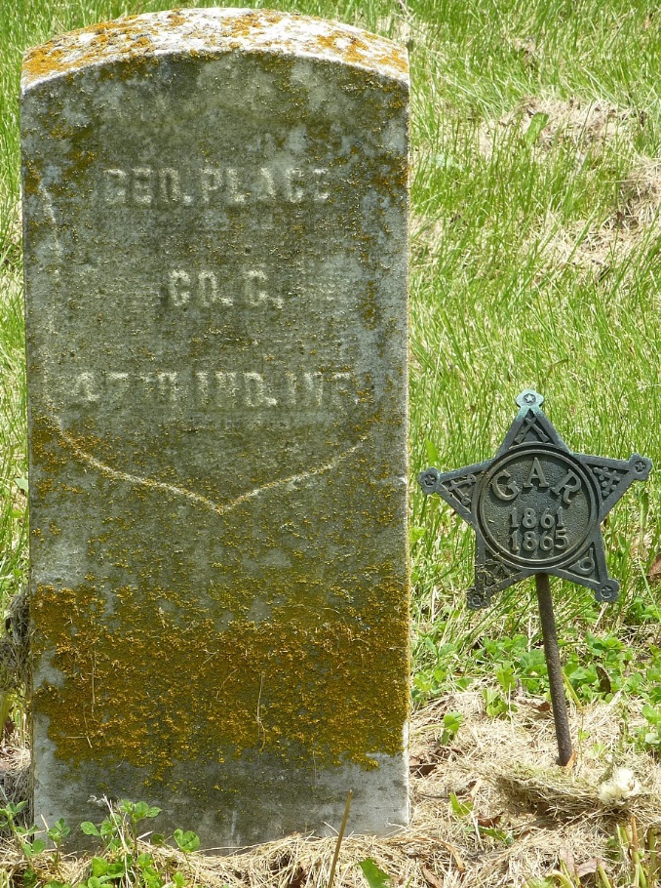
Photo by Jackie Sanders

George Place from tree Mjolsness Family Tree.
Birth 1832 Delaware, Ohio, USA
Residence Pleasant Mills, Adams, Indiana, USA
Death 7 Nov 1876 Adams, Indiana, USA
Father John Place (1787-1847)
Mother Rachel Meeker (1803-1894)

