Charley Pelz
June 25, 1882 – October 29, 1885

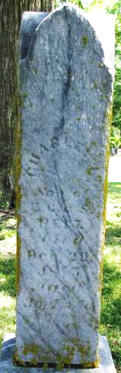
Photo by Jackie Sanders

Charles 'Charley' Pelz from tree Gorrell/Smead Family Tree
Birth 25 Jun 1882 Adams, Indiana, USA
Death 29 Oct 1885 Adams, Indiana, USA
Father Eduard "Edward" C Pelz (1836-1924)
Mother Sophia Amalia Pommerenke/Roemke/Rinkey (1837-1914)

