Amil G. Pelz
February 15, 1886 – October 9, 1887

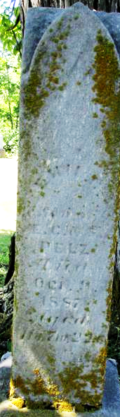
Photo by Jackie Sanders

Amil G. Pelz from tree Ayers/Pion Family Tree
Birth 15 Feb 1886 Indiana, USA
Death 9 Oct 1887 Adams, Indiana, USA
Father Herman Edward Peltz (1836-1924)
Mother Clara Sophie Pamrinka (1837-1914)

