Cora Edith (Eichar) Pearson
February 4, 1863 – May 15, 1910

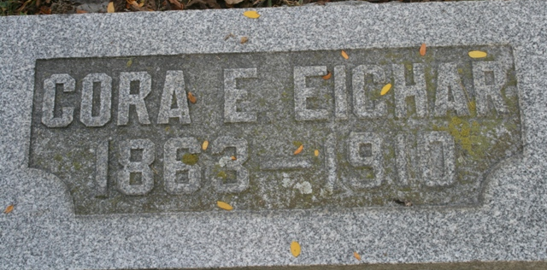
Photo by Barbara Baker Anderson

Mrs. Dot Eicher-Pierce, one of the best known and most universally esteemed residents of Willshire Township, regarded for her ever-manifested consideration of all in the wide circle of friends, has entered the windowless palace of rest. Mrs. Pierce died Saturday night, after a prolonged illness of carbuncles, at the home of her mother, Mrs. David Eicher, east of Willshire.
The funeral occurred this morning at ten o'clock, at the family home. The body was laid at rest at Pleasant Mills Cemetery.

Van Wert Daily Bulletin; Van Wert County, Ohio
May 17, 1910

**
Cora Edith Eichar from tree Diane Tree
Birth 4 Feb 1863 Adams, Indiana, USA
Marriage 1889
Residence 1910 Willshire, Van Wert, Ohio, USA
Death 15 May 1910 Willshire, Van Wert, Ohio, USA
Father David Eichar (1830-1909)
Mother Lydia Armintha Fordyce (1838-1911)
Spouse Jacob T. Pearson

