Mary E. Null
March 5, 1862 - September 19, 1863

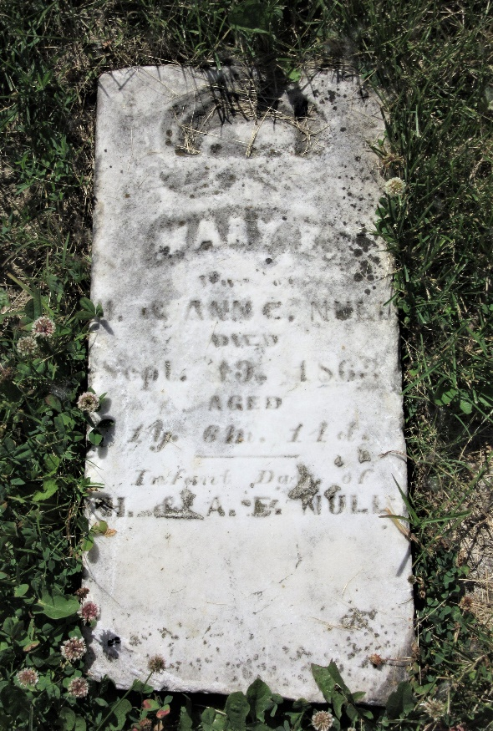
Photo by PLS

No further information found at this time

