Sarah Ann (Roebuck) Noll
January 1, 1833 – July 24, 1854

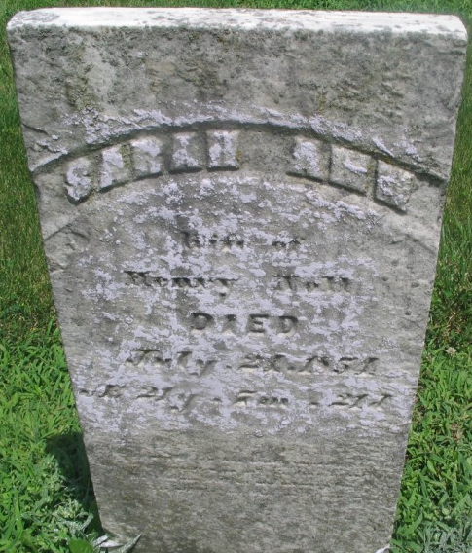
Photo by Margie Roop Pearce

Sarah Ann Roebuck from tree Gibson & Tuttle Families
Birth 1 Jan 1833 Allen, Indiana, USA
Residence 1850 Adams, Indiana, USA
Marriage 3 Oct 1852 Allen, Indiana, USA
Death 24 Jul 1854 Allen, Indiana, USA
Father John Roebuck (1802-1836)
Mother Ruth Bevington (Born 1802)
Spouse Henry K Noll (Born 1834) t Mills Cemetery

