William Lattel Neptune
March 10, 1871 – November 20, 1873

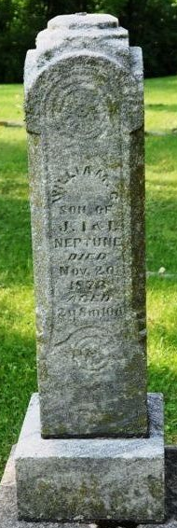
Photo by Deb Curry

William Lattel Neptune from tree NeptuneDescendancy
Birth 10 Mar 1871 Indiana, USA
Death 20 Nov 1873 Indiana, USA
Father James Ira Neptune (1826-1905)
Mother Isabelle Flagg (1835-1919)

